USING PIANOLA

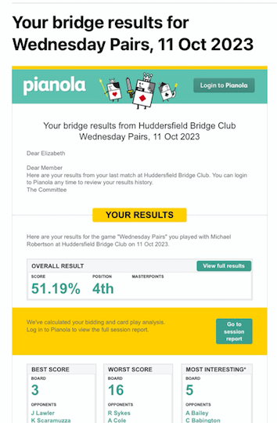
TIP ONE: VIEWING RESULTS ON YOUR PHONE

After each session, you will receive an email from Pianola with your results. It will look something like the box on the right, seen here.
Under the yellow box you will see your
overall position, and the percentage for your pair. Below the big yellow bar you will see your best, worst, and most interesting score.

By scrolling down you can see how you fared as declarer, dummy and in defence.

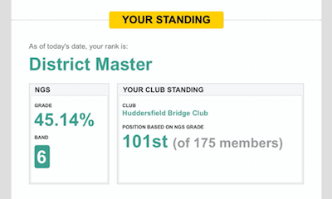
Scroll down a little further and you will see your EBU Master Status, your NGS score, and your standing against other club members.

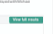
At this stage, there is NO NEED to log into Pianola, just click on
just above the big yellow bar.

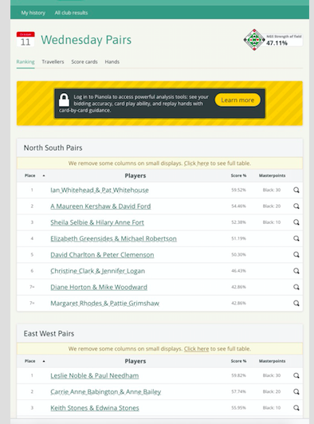
This will take you to a screen that looks something like this:
This will show you your overall position, your percentage, and any Masterpoints gained in the session.

Click on your partnership, and this will take you to your SCORECARD for the session, showing each opponent pairs, the contract bid, and by whom, and also the result, the score, and the percentage for the board.

Don’t worry about the PADLOCK icons, as they are only for members who wish to subscribe – there is no need to do this unless you really want to replay your hand in full.

Return to the screen above, and click TRAVELLERS at the top of the screen, to show each board in full, who scored what, and how you compared.
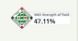
Right at the top right hand side of this screen you will see the NGS for the event.

